MobileSoftware Development

Assignment 1: Documentation

Coffee Beans



C14706715

Jake Young

DT282/3

Table of Contents

Introduction 3

Functionality: 3

Timing System 3

User 3

Mapping System 3

How To Page 3

Use Case Diagram 4

Screen Flow 4

Database 4

Description 4

Tables and Fields 4

A description of your app (about half a page of text that explains what the app does;

▪ Use case diagram(s) to show what the user(s) can use the app for;

▪ A screen flow showing the flow of screens;

▪ A database description, indicating the table(s) and fields your app will need to use

Submit the design in Webcourses as a PDF or .doc titled yourname.xxx .. e.g. JohnMurphy.pdf

# Introduction

This application is an assignment for Mobile Software Development.

This application is called Coffee Beans. Its purpose is to make Coffee enthusiasts lives that bit more easier. The finished product should have plenty of essential functionality.

## Functionality:

### Timing System

This is a timer which is used to help users time the amount of time it should take to leave your coffee grind to brew in a cafeteria in order to retrieve the optimum taste.

This page will also have calculator functionality. It will calculate the length of time you need to leave your coffee grind to brew depending on the amount of grams used. I also want to implement a short coffee brewing video to play whilst the timer is counting down.

### User

I intend on creating profiles for each user of the app. In order to use the app you must either login or signup. The details needed will be the users name, email, password and age. This will be sent to my database using MySQL.

### Mapping System

This app will also contain Google Maps functionality. I want the users to be able to see coffee shops in their area. This should automatically be generated when the user clicks to open the Mapping page.

### How To Page

Another piece I would like to implement would be a how to page. This page should describe how to make many different great cups of coffee i.e. Latte, Cappuccino, Cortado etc.

# Use Case Diagram

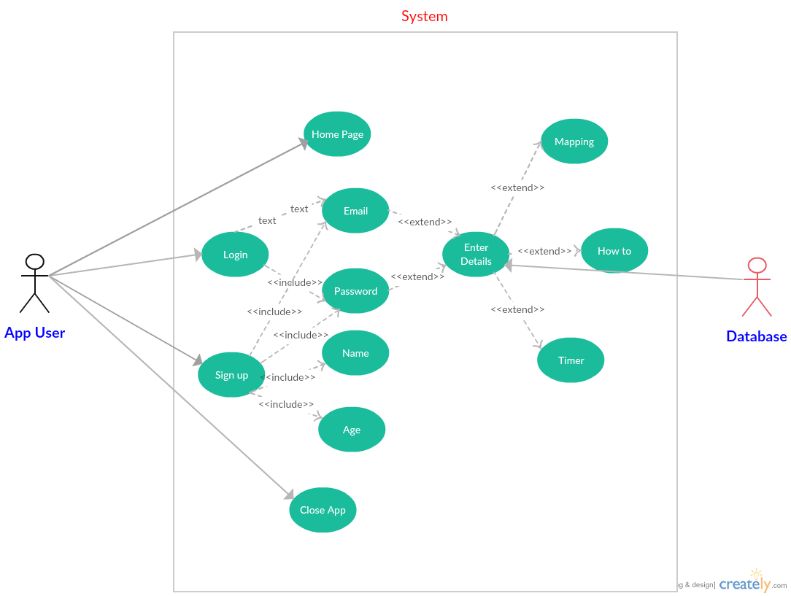

# Screen Flow

# Database

## Description

## Tables and Fields